Name

Mathematics Advanced Year 11
Graphical Applications of the Derivative

Book 4 |  | Version: 261020  Feedback:  https://MrDingMaths.com
Contents
Syllabus Content 2
Increasing Decreasing Stationary 3
Increasing Decreasing Stationary using Calculus 11

Syllabus Content
MAV-11-06 interprets the meaning of the derivative and determines the derivative of functions to solve problems
Graphical applications of the derivative
- Interpret $f\left(x\right)$ as increasing at $x=c$ when $f'\left(c\right)>0$ and decreasing at $x=c$ when $f'\left(c\right)<0$
- Describe the behaviour of a function at a point as stationary when the tangent at the point is parallel to the $x$-axis, and recognise that $f\left(x\right)$ is stationary at $x=c$ when $f'\left(c\right)=0$
- Graph $y=f^{'}(x)$ for a given graph of a function $y=f(x)$
- Numerically estimate the value of the derivative at a point on the graph of a power of $x$, with and without the use of digital tools
- Identify stationary points on the graph of a cubic function, and the values of $x$ for which the function is increasing and/or decreasing, by first calculating the derivative, and justify conclusions

Increasing Decreasing Stationary Graphically

- Behaviour of a function at a point
Decreasing at $x=a$ | Stationary at $x=a$ | Increasing at $x=a$
$$f^{'}\left(a\right)<0$$ | $$f^{'}\left(a\right)=0$$ | $$f^{'}\left(a\right)>0$$
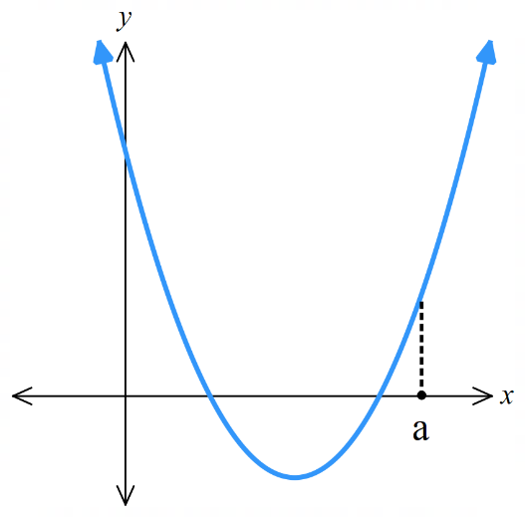
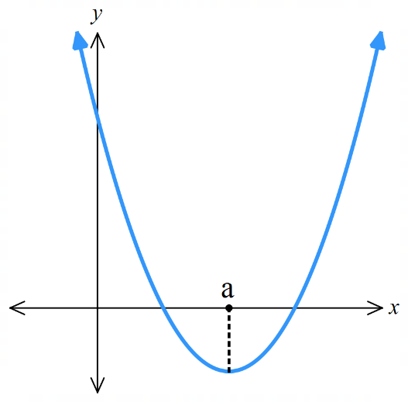
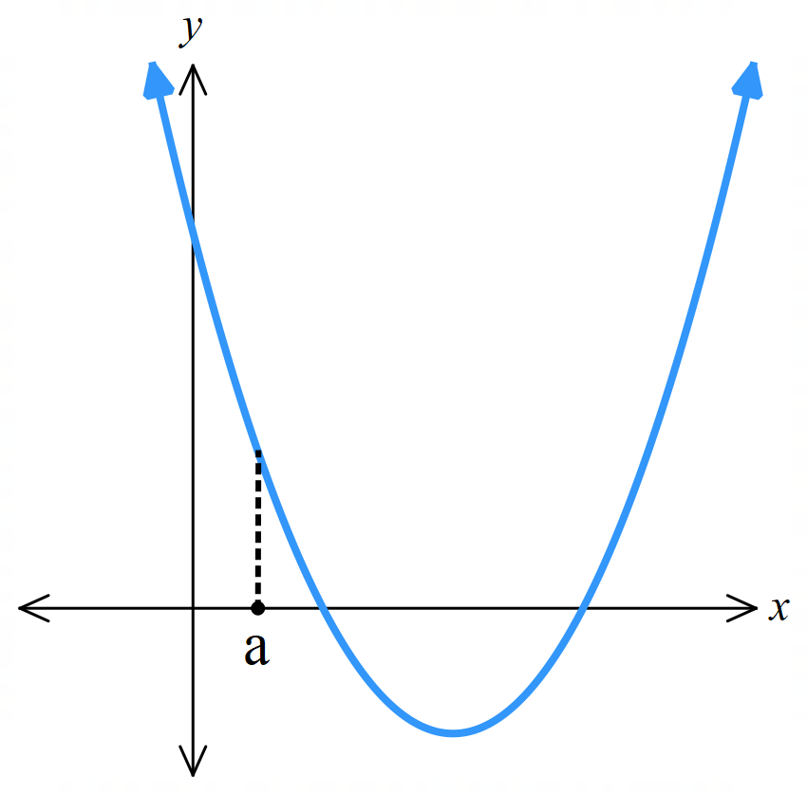

- Identify the behaviour of a curve at a point.
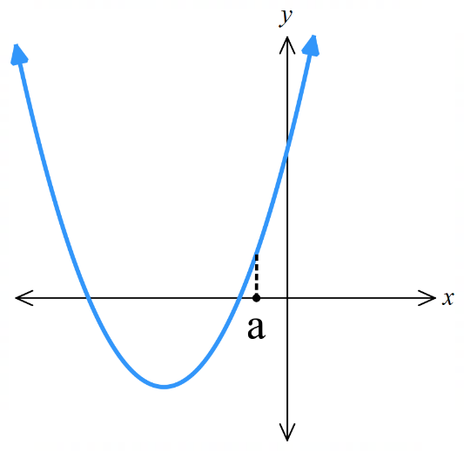  - Decreasing at $x=a$  - Stationary at $x=a$  - Increasing at $x=a$ | 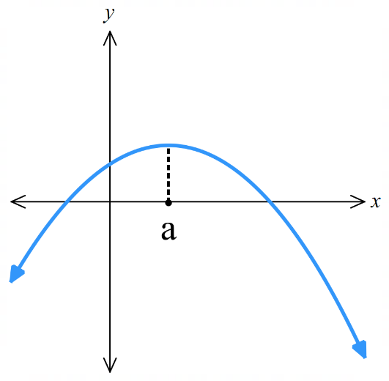  - Decreasing at $x=a$  - Stationary at $x=a$  - Increasing at $x=a$ | 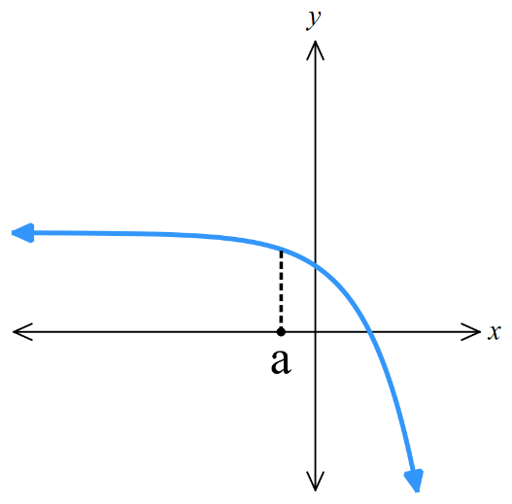  - Decreasing at $x=a$  - Stationary at $x=a$  - Increasing at $x=a$
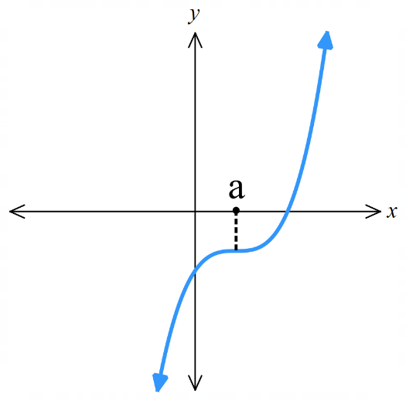  - Decreasing at $x=a$  - Stationary at $x=a$  - Increasing at $x=a$ | 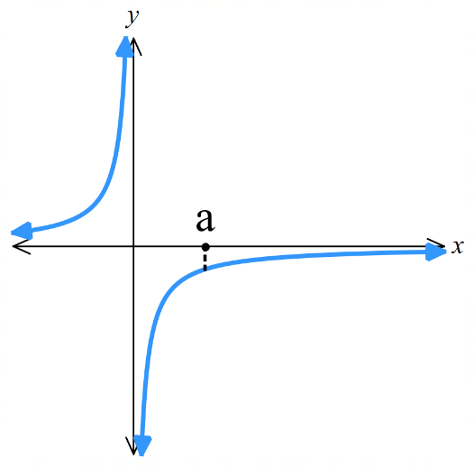  - Decreasing at $x=a$  - Stationary at $x=a$  - Increasing at $x=a$ | 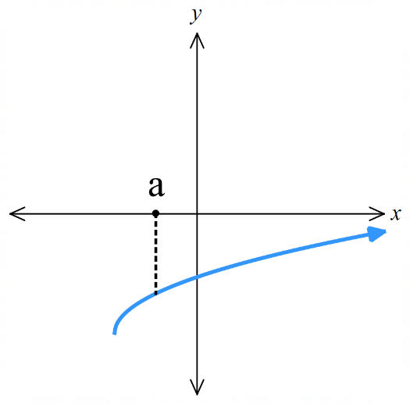  - Decreasing at $x=a$  - Stationary at $x=a$  - Increasing at $x=a$

- Identify the sign of the derivative along a curve.
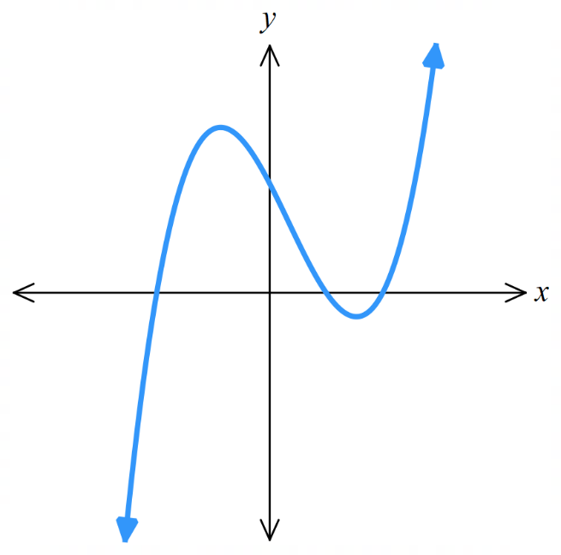
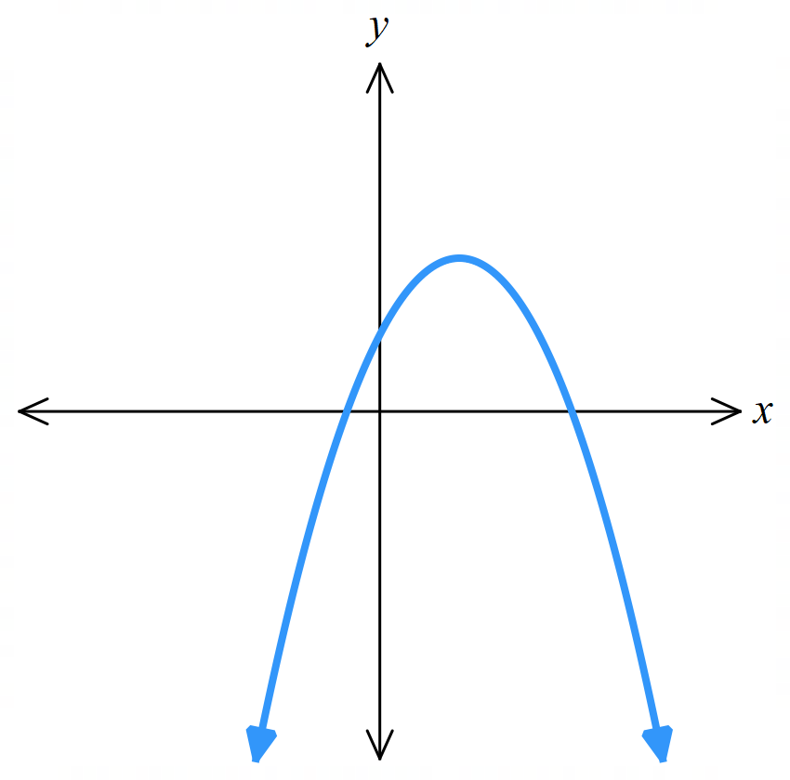
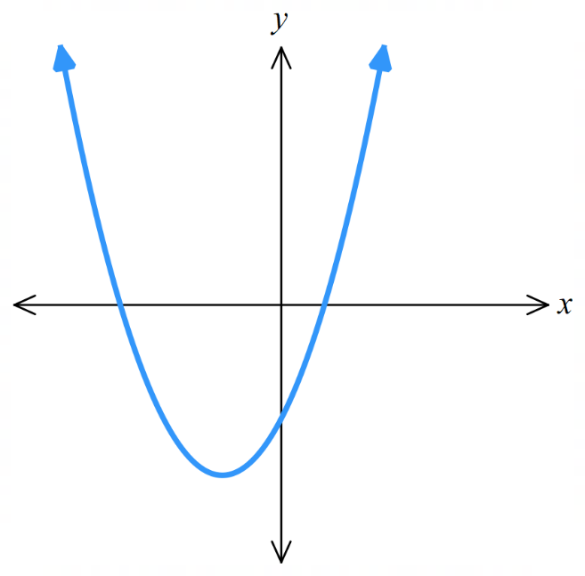

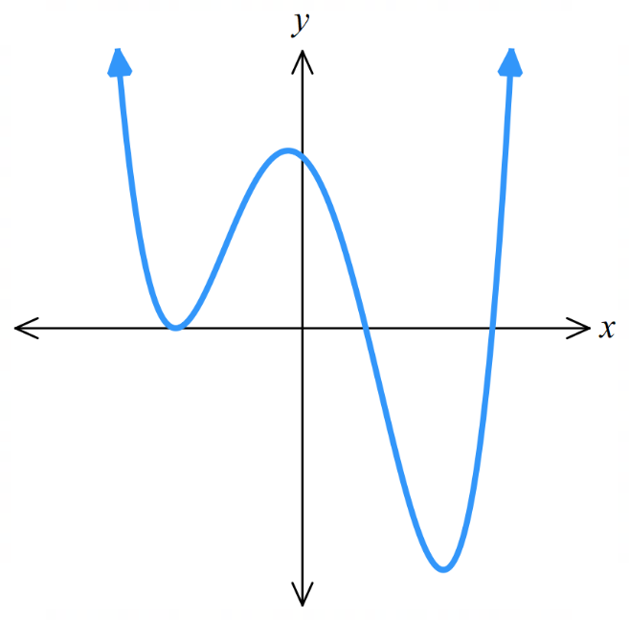
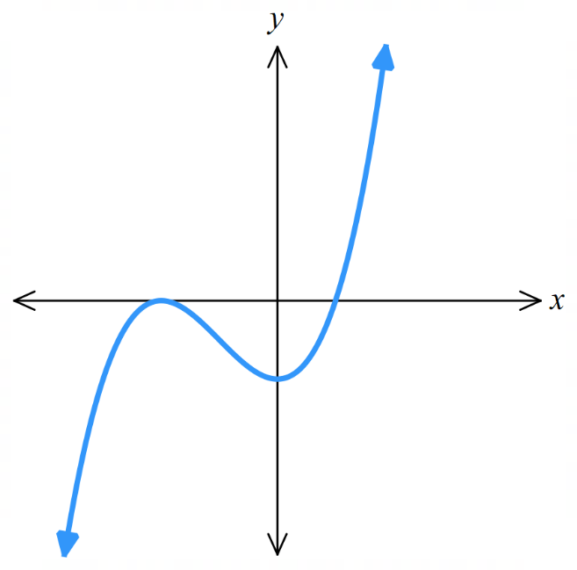
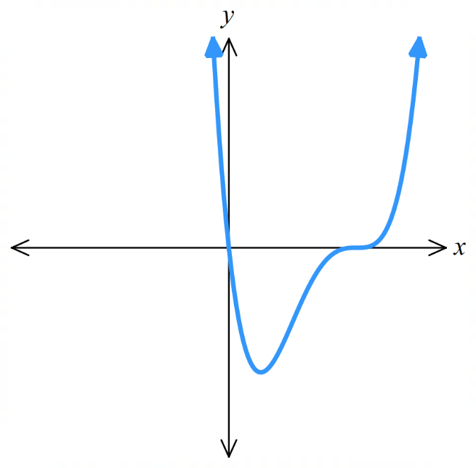

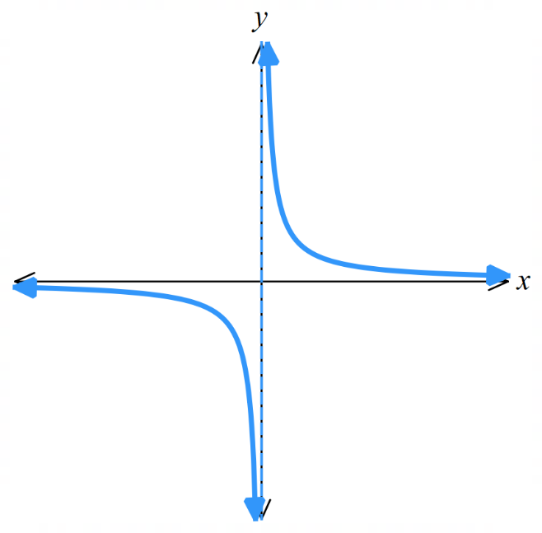 | 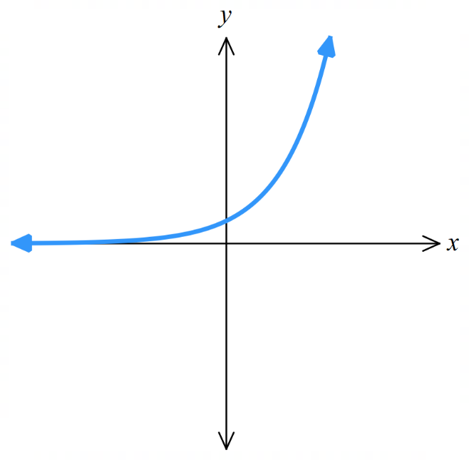 | 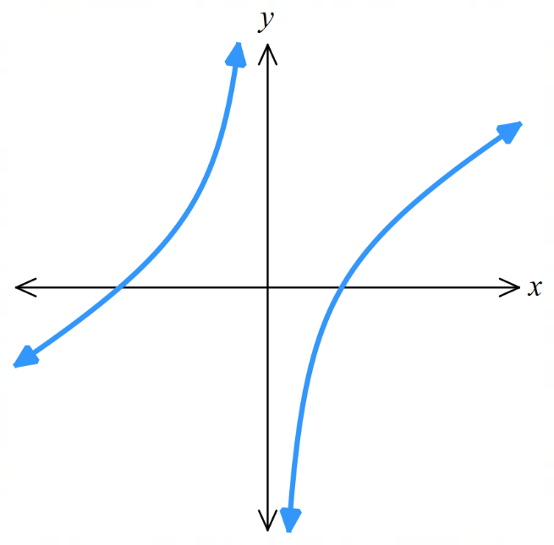
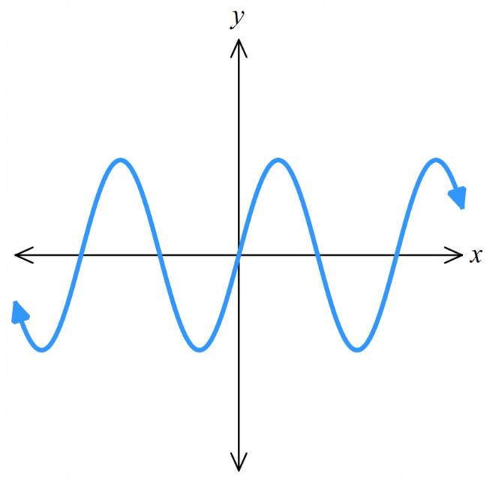 | 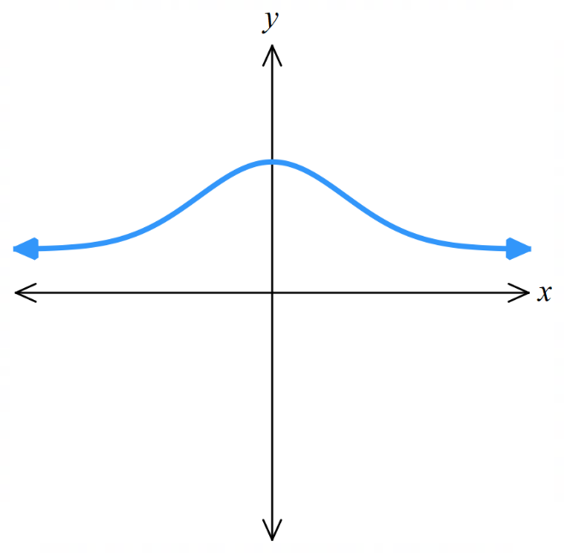 | 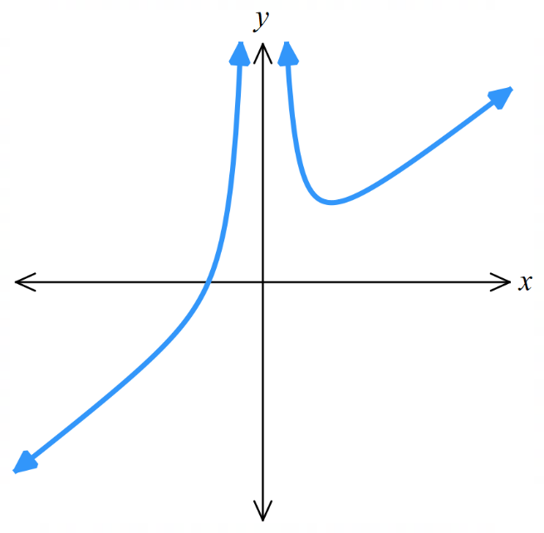

- Sketching the derivative from a given graph
- Identify the sign of the gradient along $f\left(x\right)$.
- Identify $x$ values where $f\left(x\right)$ has horizontal tangents, and mark these as zeros of $f^{'}\left(x\right)$.
- Sketch $f^{'}\left(x\right)$ using the sign of the gradient.

- Example Sketch the derivative from a given graph.
Sketch the gradient function of the given graph of $f\left(x\right)$.
1. Sign of derivative  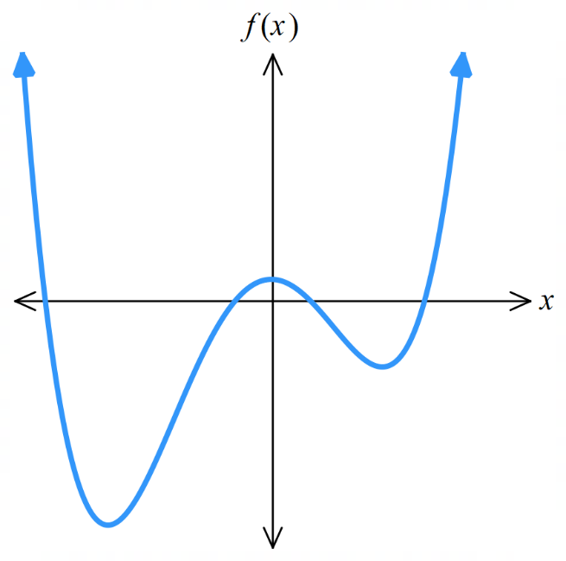  $$-$$  $$-$$  $$-$$  $$0$$  $$-$$  $$-$$  $$-$$  $$+$$  $$+$$  $$+$$  $$0$$  $$-$$  $$-$$  $$0$$  $$+$$  $$+$$  $$+$$  $$+$$  2. Identify $f^{'}\left(x\right)=0$  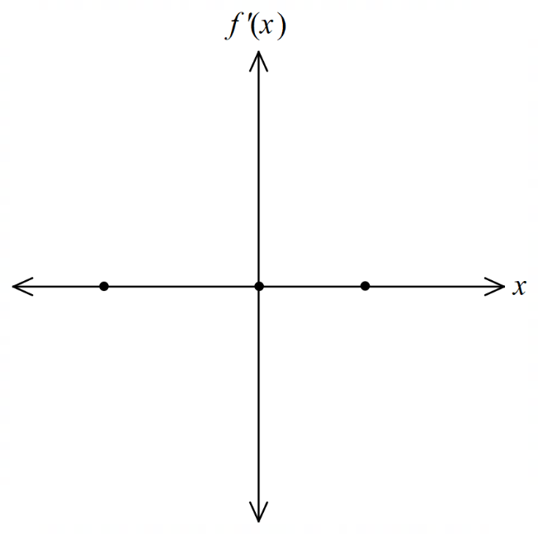  3. Sketch $f^{'}\left(x\right)$  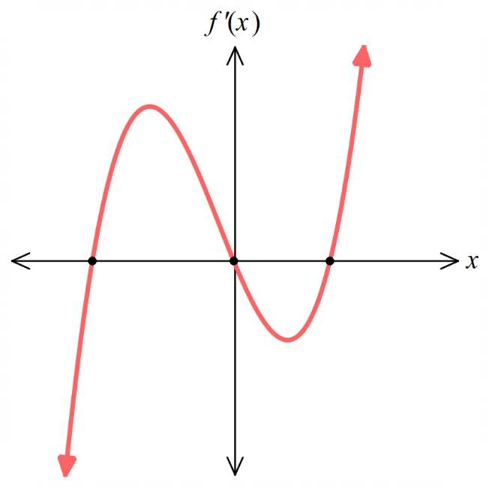 | 1. Sign of derivative  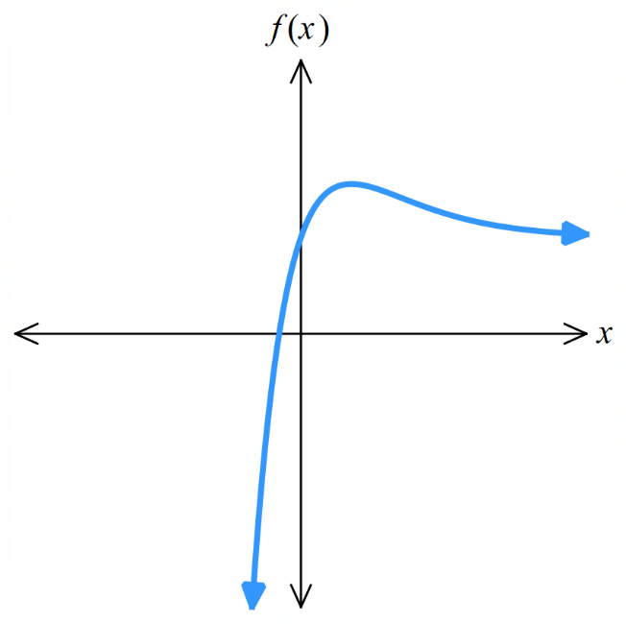  $$0$$  $$-$$  $$-$$  $$-$$  $$+$$  $$+$$  $$+$$  $$+$$  $$+$$  2. Identify $f^{'}\left(x\right)=0$  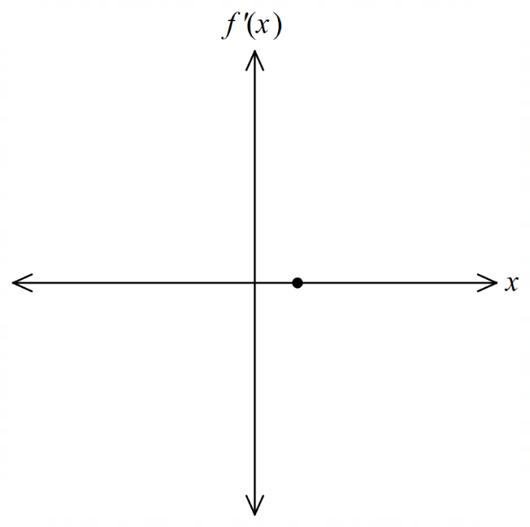  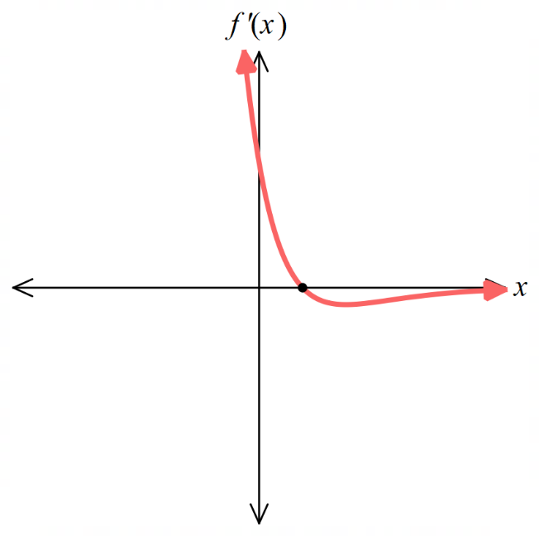  3. Sketch $f^{'}\left(x\right)$

- Practice
Sketch the derivative function
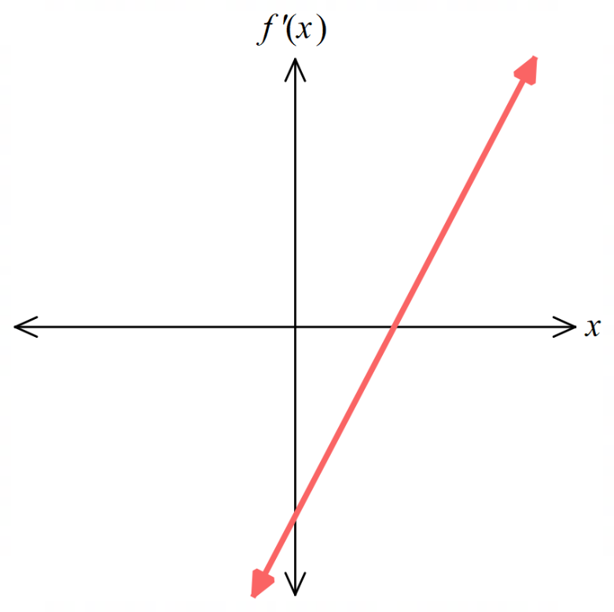 | 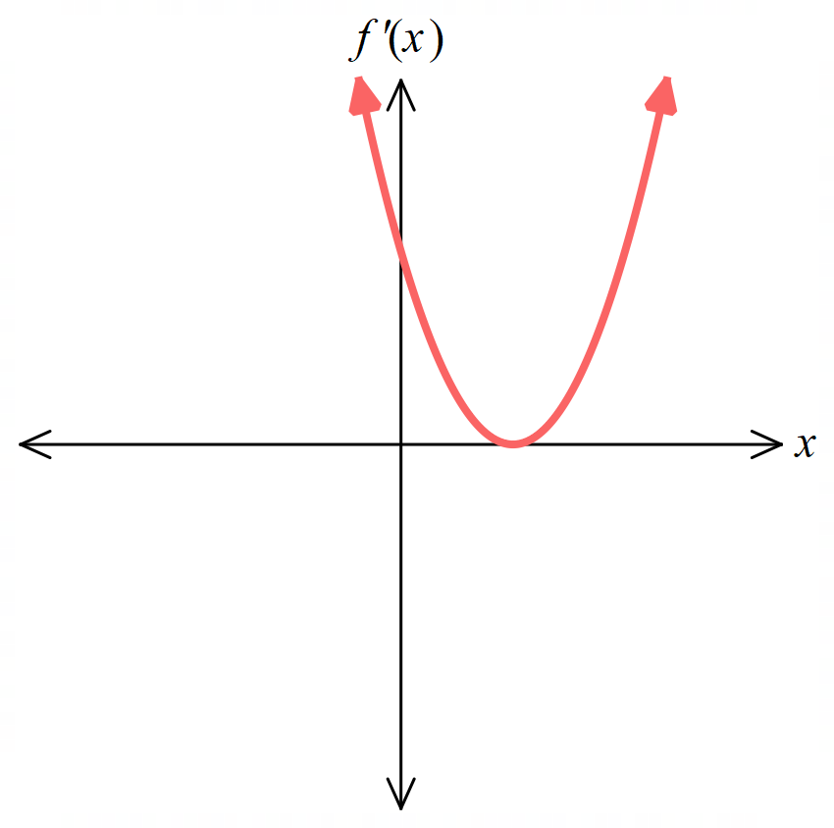  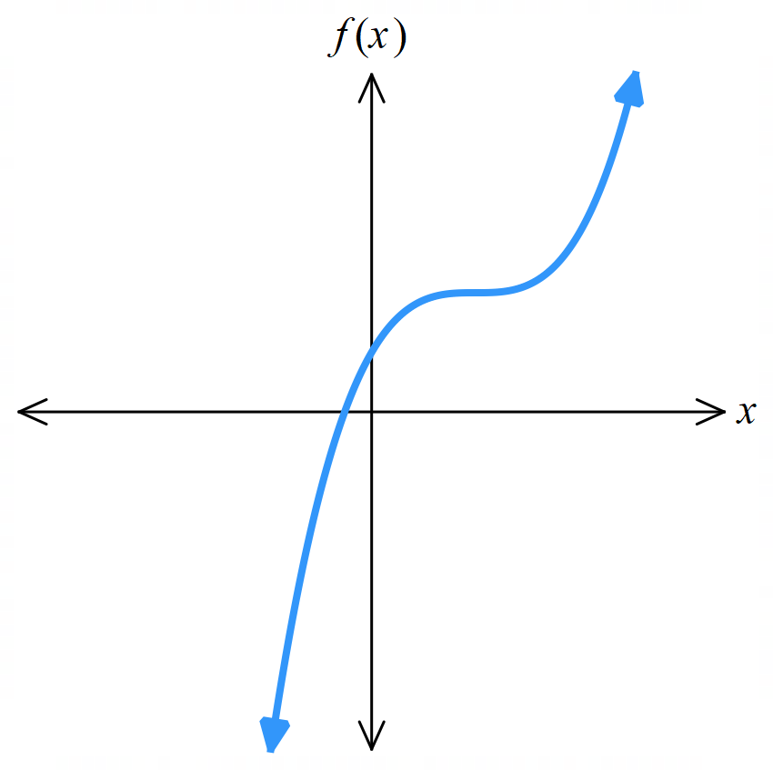  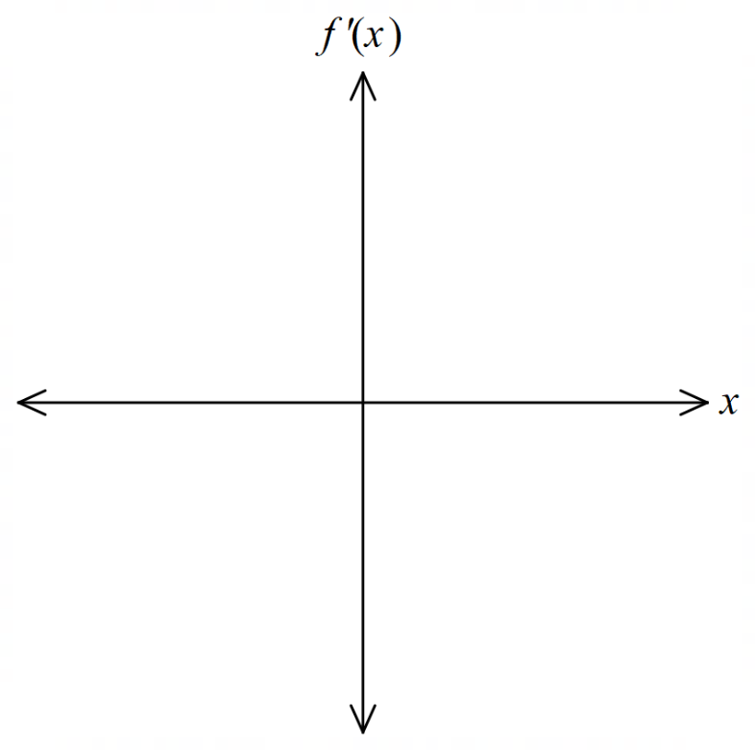  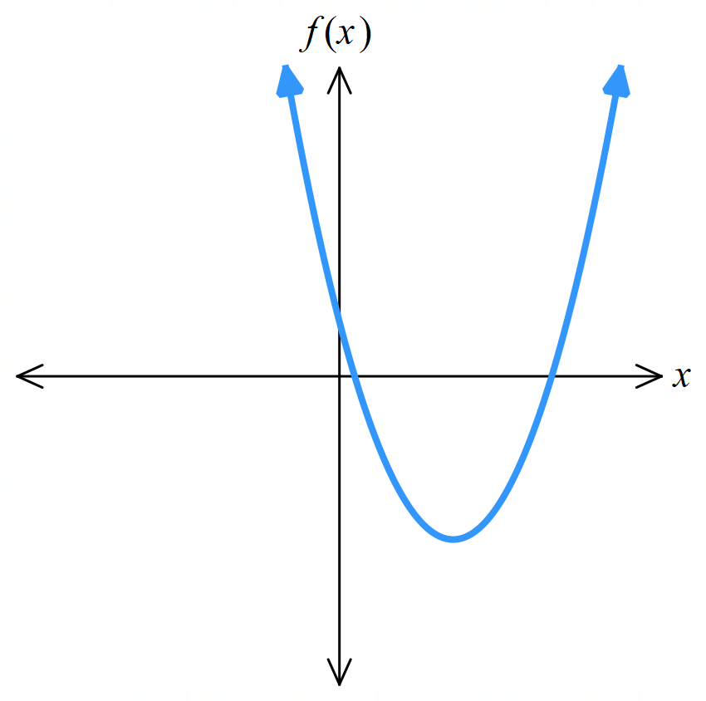
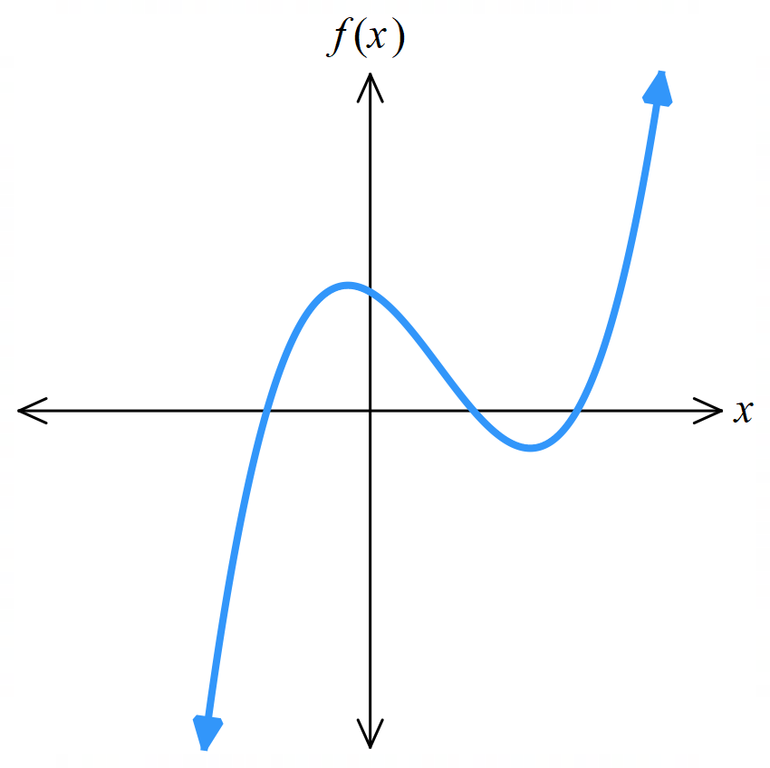  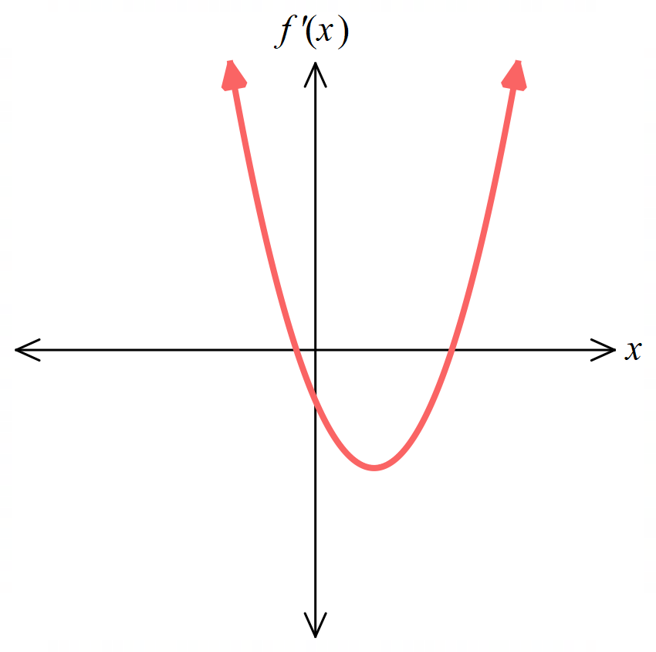 | 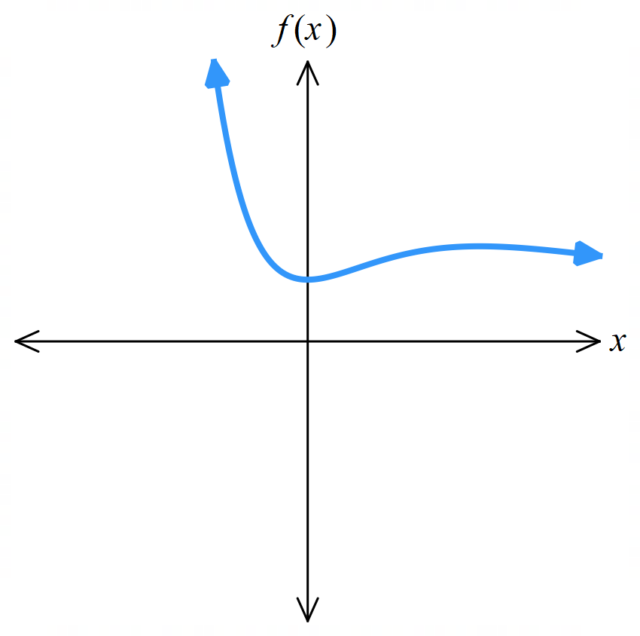  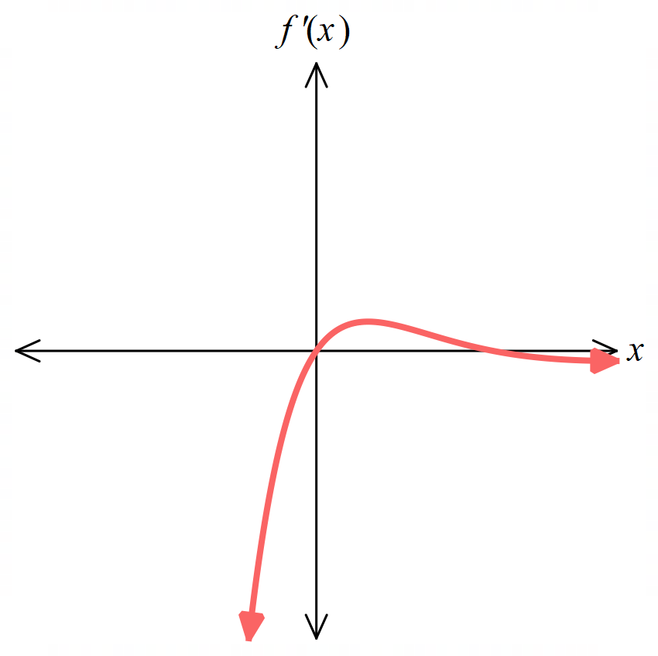

Foundation
- A function is increasing in a domain if the gradient of the tangent is p…………………
positive
- A function is decreasing in a domain if the gradient of the tangent is n…………………
negative
- When a function has a stationary point, the gradient of the tangent is …………
This can either be a t……………… point or a point of i…………………
zero, turning, inflection
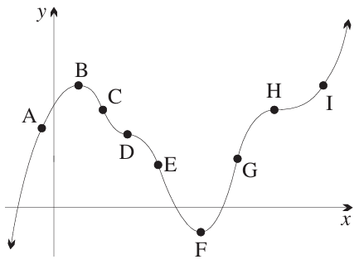
- In the diagram, name the points where:
  - $f^{'}\left(x\right)>0$.
A, G, I
  - $f^{'}\left(x\right)<0$.
C, E
  - $f'(x)=0$.
B, D, F, H

- Consider the graph of $y=f\left(x\right)$
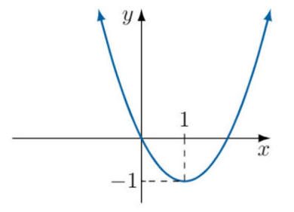
  - State the domain where the function is increasing.

$$x>1$$
  - State the domain where the function is decreasing.

$$x<1$$
  - State where the function has a horizontal tangent.

$$x=1$$
- Consider the graph of $y=f\left(x\right)$
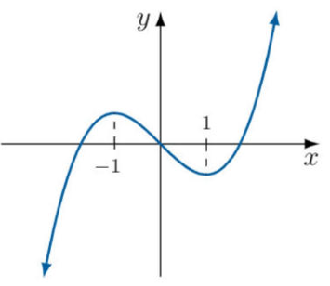
  - State where $f^{'}\left(x\right)>0.$
$$x<-1$$
$$x>1$$
  - State where $f^{'}\left(x\right)<0$.

$$-1<x<1$$
  - State where $f^{'}\left(x\right)=0$.
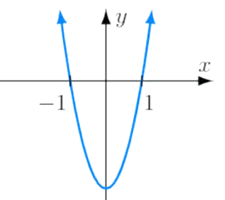
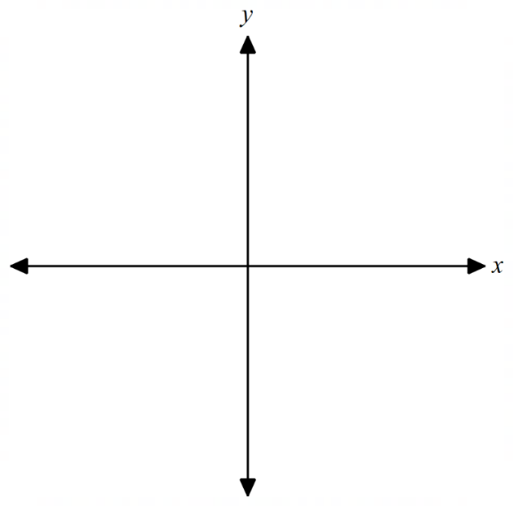
$$x=-1, 1$$
  - Hence sketch $y=f^{'}\left(x\right)$.

Development
- Sketch the derivative function for each curve.
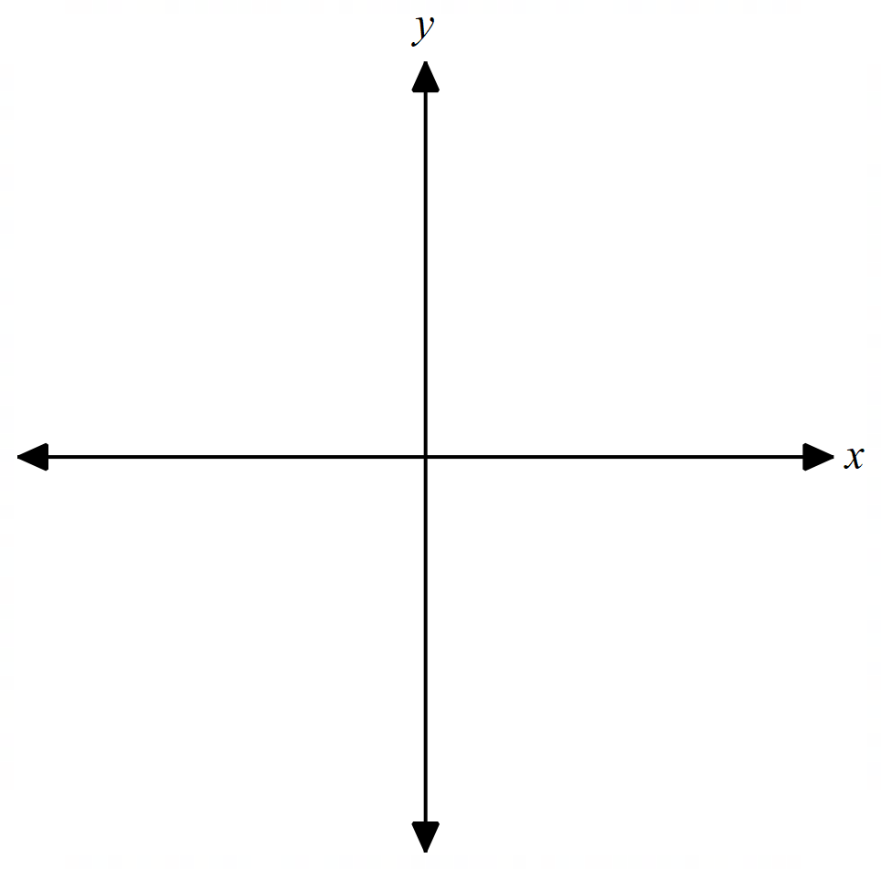
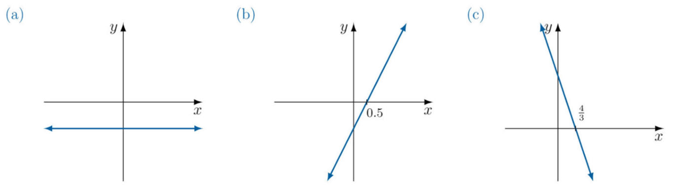
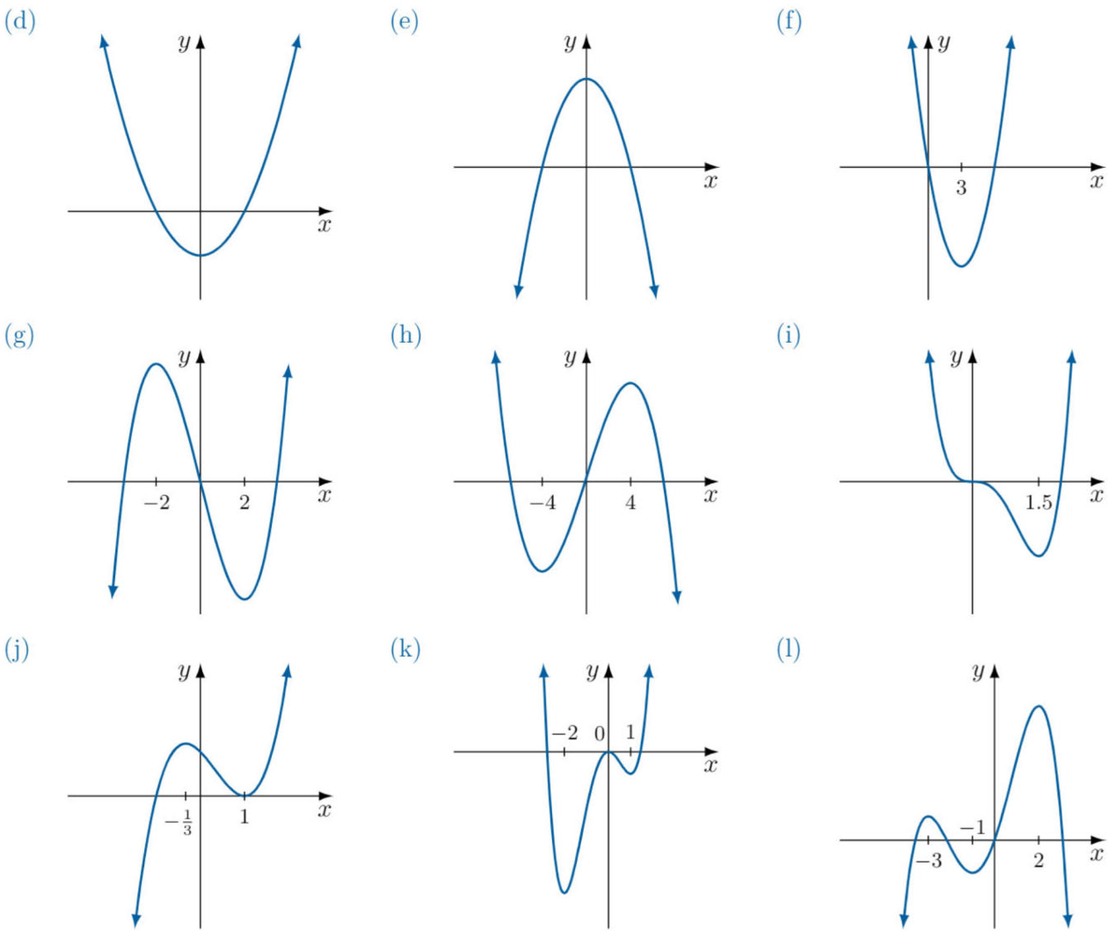
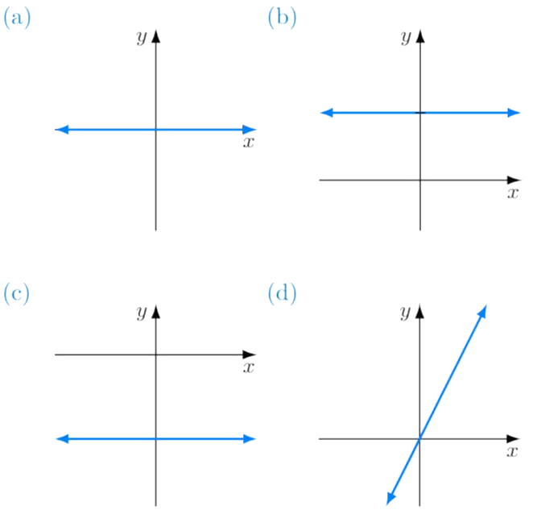
 | 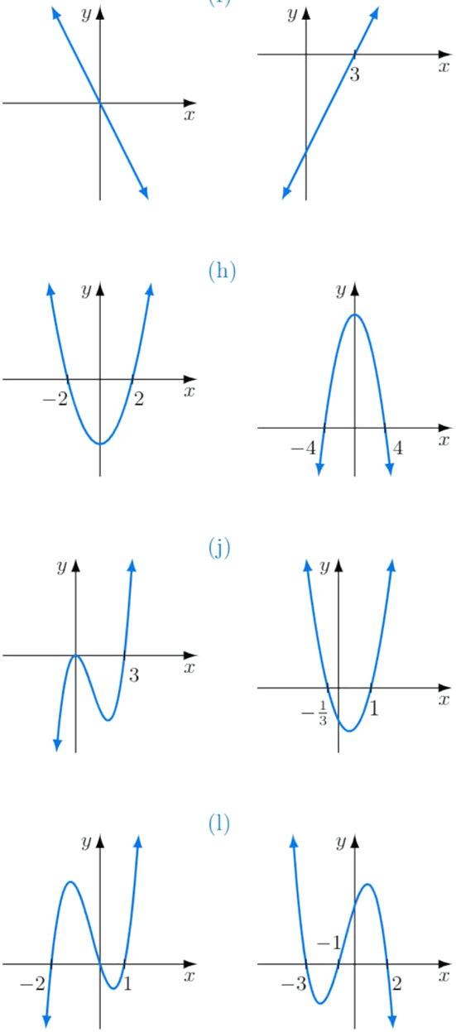
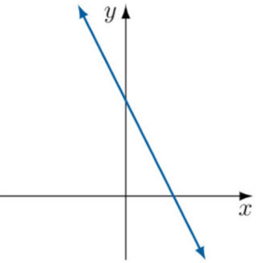  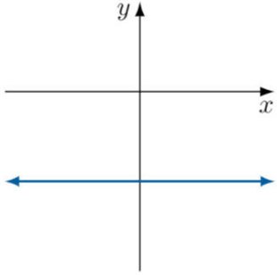 | 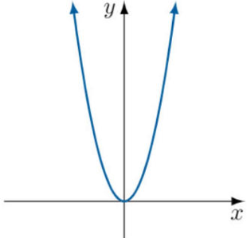  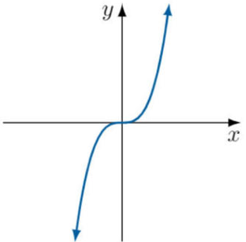 | 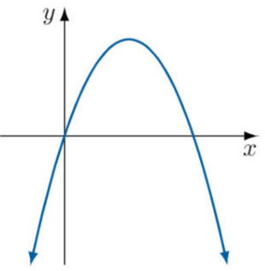  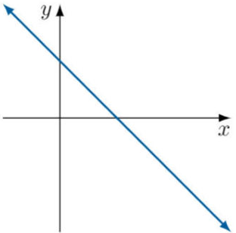
 |  | 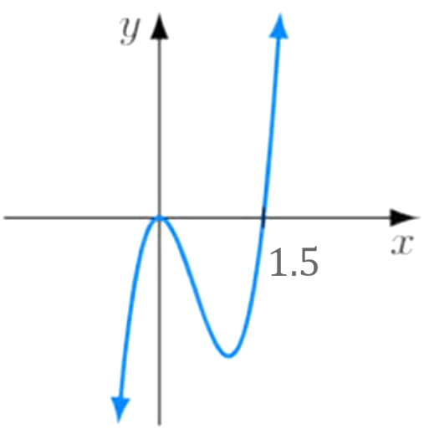

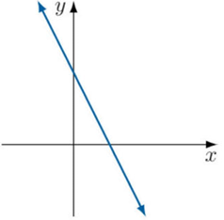
- Describe the graph of $y=f\left(x\right)$ if the graph shown below is $y=f^{'}\left(x\right)$.

Concave down parabola with vertex to the right of the $y$– axis.

Mastery
- Sketch the derivative function for each curve.
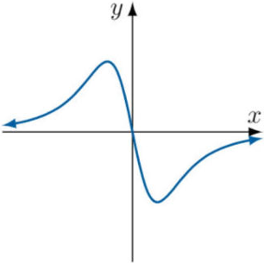  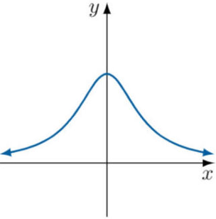 | 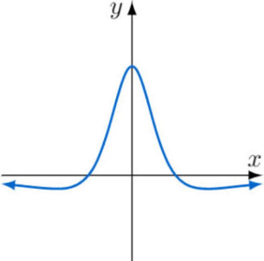  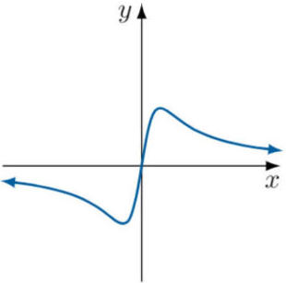 | 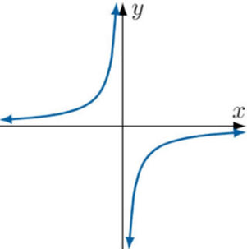  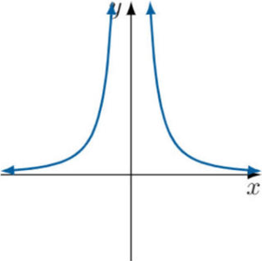
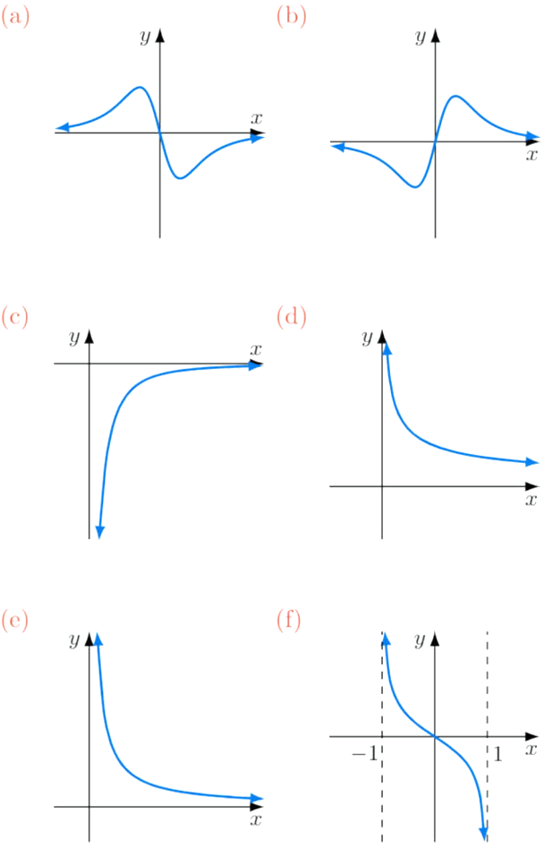  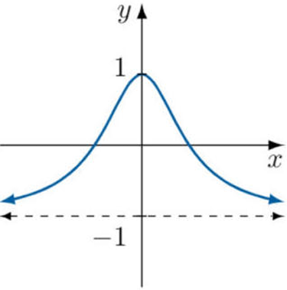 | 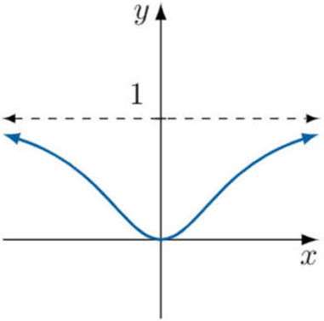 | 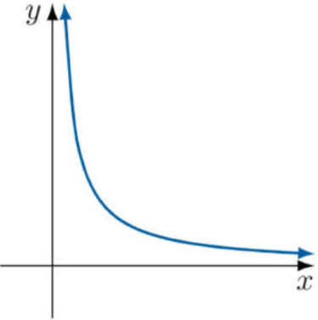
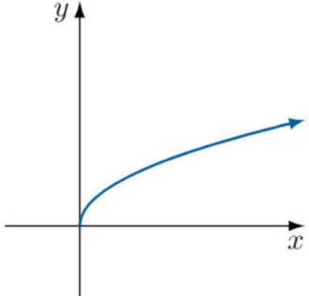 | 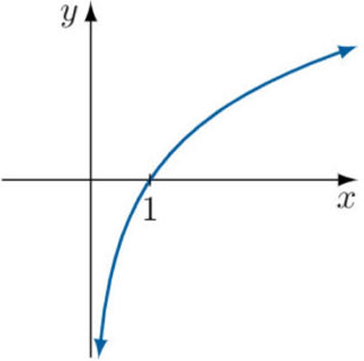 | 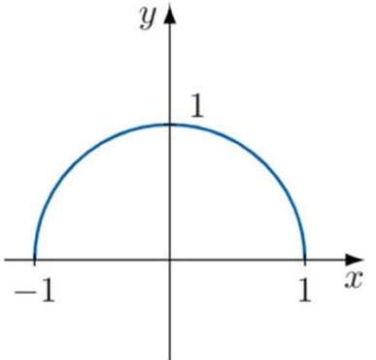

Increasing Decreasing Stationary using Calculus

- Review
- Solve inequalities
- $2x-8>0$ | - $8x+9<0$ | - $-2x+3>0$

- Solve quadratic inequalities
- $\left(x-2\right)\left(x+5\right)<0$ | - $\left(2x-1\right)\left(3x+5\right)>0$ | - $x^{2}-5x+6<0$

- Find the derivative at a point.
- $f\left(x\right)=x^{3}-2x^{2}+3$.  Find $f^{'}\left(7\right)$ | - $y=\left(x-3\right)\left(x+5\right)$.  Find $f^{'}\left(-2\right)$ | - $f\left(x\right)={\left(x-2\right)}^{3}$  Find $f^{'}\left(7\right)$

- Determining the behaviour of a curve at a point
- Differentiate to find $f^{'}\left(x\right)$.
- Evaluate $f^{'}\left(a\right)$.
  - Decreasing if $f^{'}\left(a\right)<0$.
  - Increasing if $f^{'}\left(a\right)>0$.
  - Stationary if $f^{'}\left(a\right)=0.$

- Example Determine the behaviour of a curve at a point.
Differentiate $f\left(x\right)=x^{3}-12x$ and hence determine the behaviour of the curve at:  - $x=5$  - $x=2$  - $x=0$  1. $f^{'}\left(x\right)=3x^{2}-12$  2.  a. $f^{'}\left(5\right)=63>0$  $∴$ Increasing at $x=5$  b. $f^{'}\left(2\right)=0$  $∴$ Stationary at $x=2$  c. $f^{'}\left(0\right)=-12<0$  $∴$ Decreasing at $x=0$ | What is meant by “behaviour” of a function at a point?  Behaviour describes a function’s …………… …… …………… at a point; it can be either increasing, decreasing, or stationary.  Why do we need to find the derivative first?  The derivative represents the ………… …… ………………  When is a curve increasing?  When $f^{'}\left(x\right)$ …………  When is a curve decreasing?  When $f^{'}\left(x\right)$ …………  When is a curve stationary?  When $f^{'}\left(x\right)$ …………

- Practice
$f\left(x\right)=x^{3}+2x^{2}+3$.  Determine the behaviour of the curve at  - $x=-2$  - $x=0$  - $x=2$  $$f^{'}\left(x\right)=3x^{2}+4x$$  $$f^{'}\left(-2\right)=4>0, increasing$$  $$f^{'}\left(0\right)=0, stationary$$  $$f^{'}\left(2\right)=20>0, increasing$$ | $y=\left(x-2\right)\left(x+6\right)$.  Determine the behaviour of the curve at  - $x=-2$  - $x=0$  - $x=2$  $$\frac{dy}{dx} = 2x + 4$$  $$\frac{dy}{dx}{\left.​\right|}_{-2}=0, stationary$$  $$\frac{dy}{dx}{\left.​\right|}_{0}=4, increasing$$  $$\frac{dy}{dx}{\left.​\right|}_{2}=8>0, increasing$$
- Finding stationary points
- Differentiate to find $f^{'}\left(x\right)$.
- Solve $f^{'}\left(x\right)=0$.
- Substitute value of $x$ from step 2 into $f\left(x\right)$ to find $y$-coordinate.

- Example Find stationary points of a curve.
Find the stationary points of $f\left(x\right)=x^{4}-4x$ .  $1. f^{'}\left(x\right)=4x^{3}-4$  2. Let $f^{'}\left(x\right)=0$  $4x^{3}-4=0$  $4x^{3}=4$  $x=1$  $3. f\left(1\right)={\left(1\right)}^{4}-4=-3$  $$∴ Stationary point at (1,-3)$$ | Find the stationary points of $f\left(x\right)=3x^{3}-4x$.  $1. f^{'}\left(x\right)=9x^{2}-4$  2. Let $f^{'}\left(x\right)=0$  $9x^{2}-4=0$  $$x=±\frac{2}{3}$$  $$3.f\left(-\frac{2}{3}\right)=\frac{16}{9}, f\left(\frac{2}{3}\right)=-\frac{16}{9}$$  $$∴Stationary points at \left(-\frac{2}{3},\frac{16}{9}\right), \left(\frac{2}{3}, -\frac{16}{9}\right)$$

- Practice
Find the stationary points of these functions. Check using Desmos.
- $f\left(x\right)=x^{2}+8x+16$  $$\left(-4,0\right)$$ | - $f\left(x\right)=x^{3}-48x-7$  $$(-4, 121), (4, -135)$$
- $f\left(x\right)={\left(x-2\right)}^{4}$  (2, 0) | - $f\left(x\right)=$ $\frac{x-1}{x^{2}}$  $$\left(2,\frac{1}{4}\right)$$
- Finding intervals where a curve is increasing or decreasing
- Differentiate to find $f^{'}\left(x\right)$
- Solve to find:
  - Increasing region $f^{'}\left(x\right)>0$.
  - Decreasing region $f^{'}\left(x\right)<0$.

- Example Find intervals where a curve is increasing or decreasing.
Determine the intervals where  $y=(x-2)(x-4)$  is increasing or decreasing.  1. $y=x^{2}-6x+8$  $y^{'}=2x-6$  2.  a. Increasing:  $$2x-6>0 \\ x>3$$  b. Decreasing:  $$2x-6<0 \\ x<3$$ | Determine the intervals where  $f\left(x\right)=x^{3}+2x^{2}+3$  is increasing or decreasing.  1. $f^{'}\left(x\right)=3x^{2}+4x$  $$=x\left(3x+4\right)$$  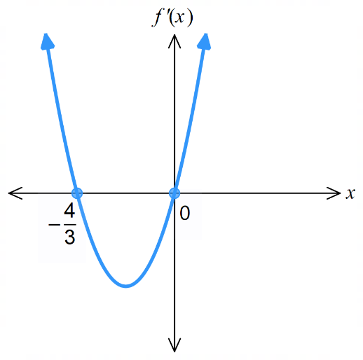  2.  a. Increasing:  $$x\left(3x+4\right)>0 \\ x>0, x<-\frac{4}{3}$$  b. Decreasing:  $$x\left(3x+4\right)<0$$  $$-\frac{4}{3}<x<0$$

- Practice
Find where the curve is increasing or decreasing.
- $y=-2x^{2}+8x-1$  Increasing: $x<2$  Decreasing: $x>2$ | - $y=2x^{2}-x$  Increasing: $x>$ $\frac{1}{4}$  Decreasing: $x<$ $\frac{1}{4}$
- $y=x^{3}-3x$  Increasing: $x<-1, x>1$  Decreasing: $-1<x<1$ | - $y=4x^{3}-24x^{2}+36x-8$  Increasing: $x<1 or x>3$  Decreasing: $1<x<3$

Foundation

  - Find the derivative of $f\left(x\right)=x^{2}-6x+11$.
$$f'(x) = 2x - 6$$
  - Hence determine whether the curve is increasing, decreasing, or stationary at:
$$x=0$$  f'(0) = -6 (decreasing) | $$x=1$$  f'(1) = -4 (decreasing) | $$x=3$$  f'(3) = 0 (stationary) | $$x=4$$  f'(4) = 2 (increasing) | $$x=-1$$  f'(-1) = -8 (decreasing)

  - Find the derivative of $f\left(x\right)=x^{3}-6x^{2}+9$.
$$f'(x) = 3x² - 12x$$
  - Hence determine whether the curve is increasing, decreasing, or stationary at:
$$x=0$$  f'(0) = 0 (stationary) | $$x=1$$  f'(1) = -9 (decreasing) | $$x=2$$  f'(2) = -12 (decreasing) | $$x=3$$  f'(3) = -9 (decreasing) | $$x=-1$$  f'(-1) = 15 (increasing)

- Differentiate each function then determine whether the curve is increasing, decreasing, or stationary at $x=0$.
- $y={\left(x-1\right)}^{3}$  $$y' = 3(x - 1)²$$  y'(0) = 3(1)² = 3 (increasing) | - $y={\left(2x-1\right)}^{4}$  $$y' = 8(2x - 1)³$$  y'(0) = 8(-1)³ = -8 (decreasing) | - $y={\left(x^{2}+3\right)}^{2}$  $$y’=4x(x² + 3)$$  y'(0) = 0 (stationary)

- Differentiate each function then determine whether the curve is increasing, decreasing, or stationary at $x=1$.
- $y=\left(x-5\right)\left(x+3\right)$  $$y' = 2x - 2$$  y'(1) = 0 (stationary) | - $y=(x-2)(x^{2}+5)$  $$y' = 3x² - 4x + 5$$  y'(1) = 4 (increasing) | - $y=(x^{4}+2)(1-x^{3})$  $$y' = 4x³ - 7x⁶ - 6x²$$  y'(1) = -9 (decreasing)

- Differentiate each function then determine whether the curve is increasing, decreasing, or stationary at $x=2$.
- $y=$ $\frac{x}{x+1}$  $$y^{'}=\frac{1}{{\left(x+1\right)}^{2}}$$  y'(2) = 1/9 (increasing) | - $y=$ $\frac{x+1}{x-1}$  $$y^{'}=-\frac{2}{{\left(x-1\right)}^{2}}$$  y'(2) = -2 (decreasing) | - $y=$ $\frac{x^{2}}{x+2}$  $$y^{'}=\frac{x^{2}+ 4x}{{\left(x+2\right)}^{2}}$$  $$y'(2) =\frac{3}{4} (increasing)$$

- Find the coordinates of the stationary points of each function.
- $y=x^{2}-2x$  (1, -1) | - $y=x^{2}-4x+3$  (2, -1) | - $y=x^{2}+6x+9$  (-3, 0)
- $y=2x^{2}-16x$  (4, -32) | - $y=x^{3}-3x^{2}$  (0, 0), (2, -4) | - $y=x^{3}-12x$  (-2, 16), (2, -16)

- Show that $y=-5x+2$ is decreasing for all $x$.
$y' = -5$ < 0 for all $x$
- Show that $y=x+7$ is increasing for all $x$.
$y^{'}=1>0$ for all $x$
- Show that $y=x^{3}$ is increasing for all values of $x$, apart from $x=0$.

$y^{'}=3x^{2}>0$ for all $x$, except $x=0$ where $y^{'}=0$
- Show that $y=3x^{2}$ is increasing for $x>0$ and decreasing for $x<0$. What happens at $x=0$?

$y^{'}=6x.$When $x>0, y^{'}>0,$when $x<0, y^{'}<0$
when $x=0, y^{'}=0$, so it is a stationary point.
- Show that $y=\sqrt{x}$ is increasing for its entire domain.
$$y^{'}=\frac{1}{2\sqrt{x}}, y^{'}>0 in the domain x>0.$$
Note: this is not a rigorous enough proof, as the function is defined at $x=0$ but the derivative is not,
but this is sufficient for the HSC definition of increasing/decreasing functions.

Development
- $f\left(x\right)=4x-x^{2}$
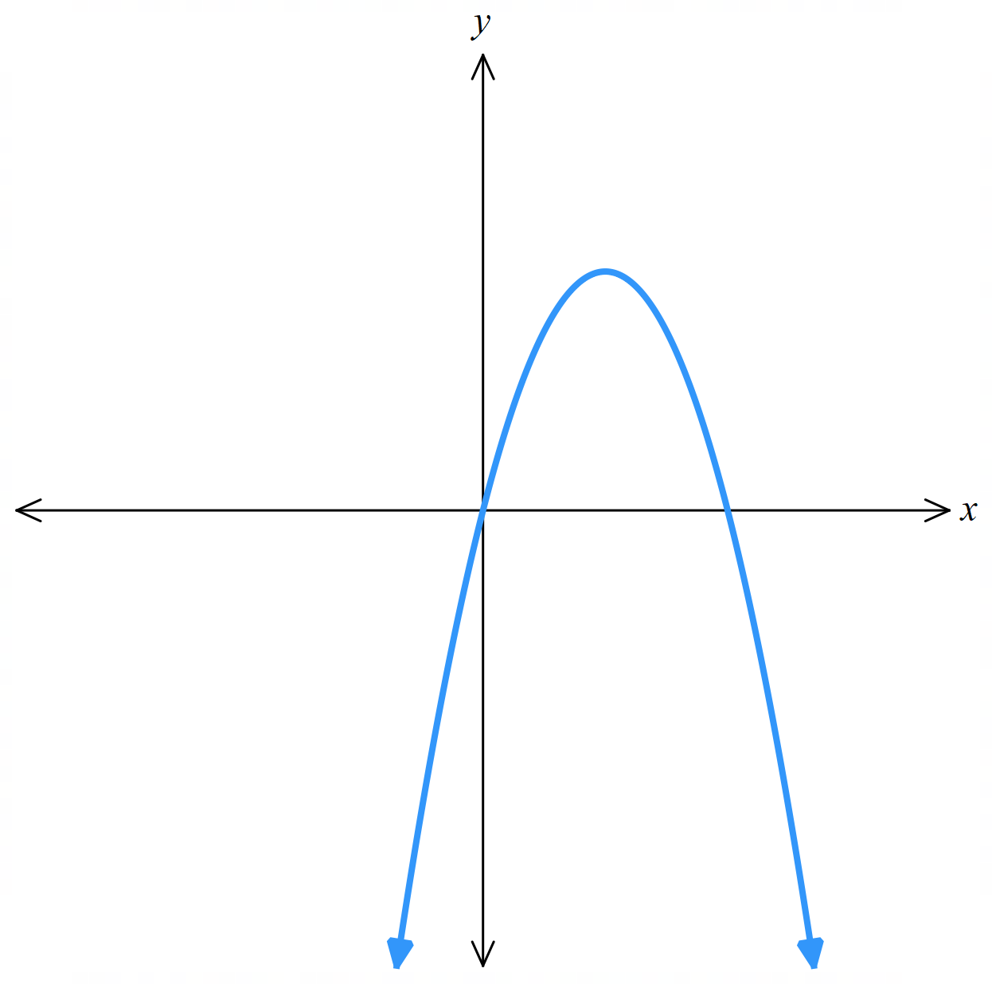
  - Find $f^{'}\left(x\right)$.
$$\left(2,4\right)$$
$$4$$
$$0$$
$$f^{'}\left(x\right)=4-2x$$
  - For what values of $x$ is $f\left(x\right)$:
    - Increasing
$$x<2$$
    - Decreasing
$$x>2$$
    - Stationary
$$x=2$$
  - By finding $f\left(2\right)$, label the sketch of $y=f\left(x\right)$ to the right.

- $f\left(x\right)=x^{3}-3x^{2}+5$
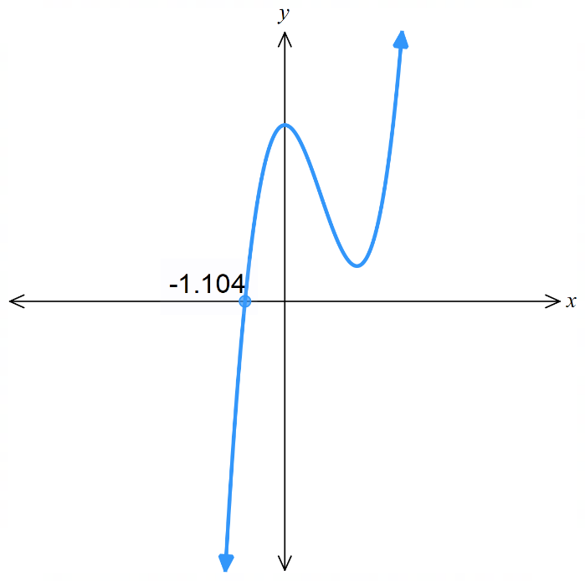
  - Find $f^{'}\left(x\right)$
$$\left(2,1\right)$$
$$5$$
$$f^{'}\left(x\right)=3x^{2}-6x$$
  - For what values of $x$ is $f\left(x\right)$:
    - Increasing
$$x<0, x>2$$
    - Decreasing
$$0<x<2$$
    - Stationary
$$x=0,2$$
  - By finding $f\left(0\right)$ and $f\left(2\right)$, label the sketch of $y=f\left(x\right)$ to the right.

  - Differentiate $f\left(x\right)=-$ $\frac{3}{x}$ and show that $f'\left(x\right)>0$ for all $x$ in its domain.

$$f^{'}\left(x\right)=\frac{3}{x^{2}}>0 for all x$$
  - Explain why $f\left(-1\right)>f\left(2\right)$, despite $f'\left(x\right)>0$.

There is an asymptote at $x=0$. The hyperbola is not continuous.

- Find the derivative of each function, and by solving $y^{'}>0$, find the values of $x$ for which the function is increasing.
- $y=x^{2}-4x+1$  $$x>2$$ | - $y=7-6x-x^{2}$  $$x<-3$$
- $y=2x^{3}-6x$  $$x>1 or x<-1$$ | - $y=x^{3}-3x^{2}+7$  $$x<0 or x>2$$

- Find the values of $x$ for which:
- $y=x^{3}-x^{2}-x-1$ is decreasing.  $$-\frac{1}{3}<x<1$$ | - $y=x^{3}-3x^{2}-24x+15$ is increasing.  $$x<-2 or x>4$$

- Use the quotient rule to find $f^{'}\left(x\right)$ and hence show that:
  - $f\left(x\right)=$ $\frac{2x}{x-3}$ is decreasing for all $x$, $x≠3$.

$$f^{'}\left(x\right)=-\frac{6}{{\left(x-3\right)}^{2}}<0 for x≠3$$
  - $f\left(x\right)=$ $\frac{x^{3}}{x^{2}+1}$ is increasing for all $x$, except $x=0$ where it is stationary.

$$f^{'}\left(x\right)=\frac{x^{2}\left(x^{2}+3\right)}{{\left(x^{2}+1\right)}^{2}}>0 for x≠0$$
- 2021 HSC Advanced Band 4
For what values of $x$ is $f\left(x\right)=x^{2}-2x^{3}$ increasing?

$$f^{'}\left(x\right)= 2x - 6x^{2}>0$$
$$0< x<\frac{1}{3}$$

Mastery
- 2010 HSC Advanced Band 5
$f\left(x\right)=x^{3}-3x^{2}+kx+8$. Find the values of $k$ for which $f(x)$ is an increasing function.
$$f'(x) = 3x² - 6x + k$$
$$For 3x^{2}- 6x + k> 0:$$
$Discriminant< 0$ ($f^{'}\left(x\right)$ has no $x$-intercepts.
$${\left(-6\right)}^{2}- 4\left(3\right)\left(k\right)< 0$$
$$36 - 12k< 0$$
$$36< 12k$$
$$k> 3$$
https://www.desmos.com/calculator/cqn0cgsbj3
- 2018 HSC Advanced Band 5
$f\left(x\right)=x^{3}+kx^{2}+3x-5$. Find the values of $k$ for which $f(x)$ has no stationary points.

$$f'(x) = 3x² + 2kx + 3$$
$$For no stationary points: f'(x) ≠ 0 for all x$$
$$For quadratic 3x² + 2kx + 3 to have no real roots:$$
$$Discriminant < 0$$
$$(2k)² - 4(3)(3) < 0$$
$$4k² - 36 < 0$$
$$\left(k-3\right)\left(k+3\right) < 0$$
$$-3 < k < 3$$
https://www.desmos.com/calculator/b4rhzq7cea
- 2009 HSC Advanced Band 5
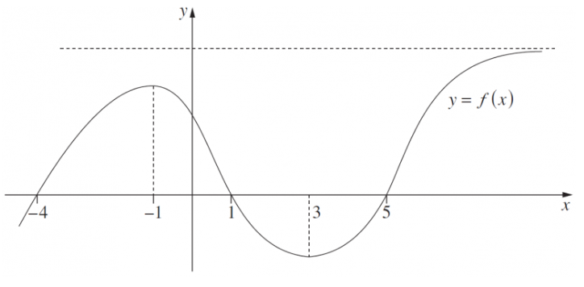
The diagram shows the graph of a function $y=f\left(x\right)$

  - For which values of $x$ is the derivative $f^{'}\left(x\right)$ negative?
$$-1<x<3$$
  - What happens to $f'(x)$ for large values of $x$?
$$f^{'}\left(x\right)→0^{+}$$
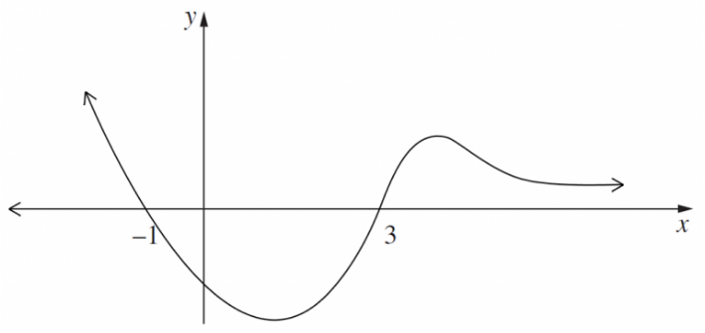
  - Sketch the graph of $y=f'(x)$.

  - Find $f^{'}\left(x\right)$ for the function $f\left(x\right)=\frac{x^{3}}{3}+x^{2}+5x+7$.

$$f'(x) = x² + 2x + 5$$
  - By completing the square, show that $f^{'}\left(x\right)$ is always positive, and hence that $f\left(x\right)$ is increasing for all $x$.

$f^{'}\left(x\right)= (x + 1)² + 4$,
since ${\left(x+1\right)}^{2}≥0$, $f^{'}\left(x\right)≥4>0$ so $f\left(x\right)$ is always increasing.
  - Explain why the equation $f\left(x\right)=0$ has exactly one real solution.

Since $f(x)$ is strictly increasing, is continuous for all $x$, and its domain is not restricted, it can cross the $x$-axis at most once.
Therefore, it has exactly one real solution.

- For $f\left(x\right)=$ $\frac{1-x^{2}}{x^{2}+1}$
  - Find $f^{'}\left(x\right)$.
  - Evaluate $f'\left(0\right).$
  - Show that $f\left(x\right)$is even.
  - Hence explain why $f\left(x\right)≤1$ for all $x$.
$$a) f^{'}\left(x\right)=-\frac{4x}{{\left(x^{2}+1\right)}^{2}}$$
$$b) f^{'}\left(0\right)=0$$
$$c) f\left(-x\right)=\frac{1-{\left(-x\right)}^{2}}{{\left(-x\right)}^{2}+1}$$
$$=\frac{1-x^{2}}{x^{2}+1}$$
$$= f\left(x\right)$$
$$Therefore f(x) is even.$$
$$d) we have f'(x)<0 for x>0$$
$$and f'(x)>0 for x<0$$
$$and f^{'}\left(x\right)=0 at x=0,$$
$$therefore f(x) has maximum value 1 at x = 0$$

